5.4 Logarithmic Functions and Models

Review of Inverses
If f(x) and g(x) are inverses, then f(x) = y and g(y) = x.

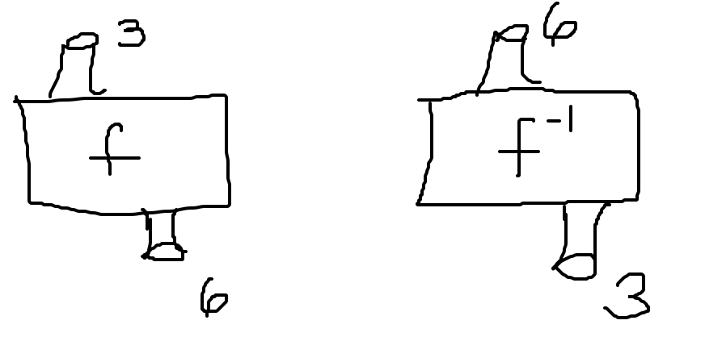

Find the inverse function of f(x) = 3x - 2. What is f(2)? If we substitute the value you get for f(2) into the inverse of f(x), what should you get?
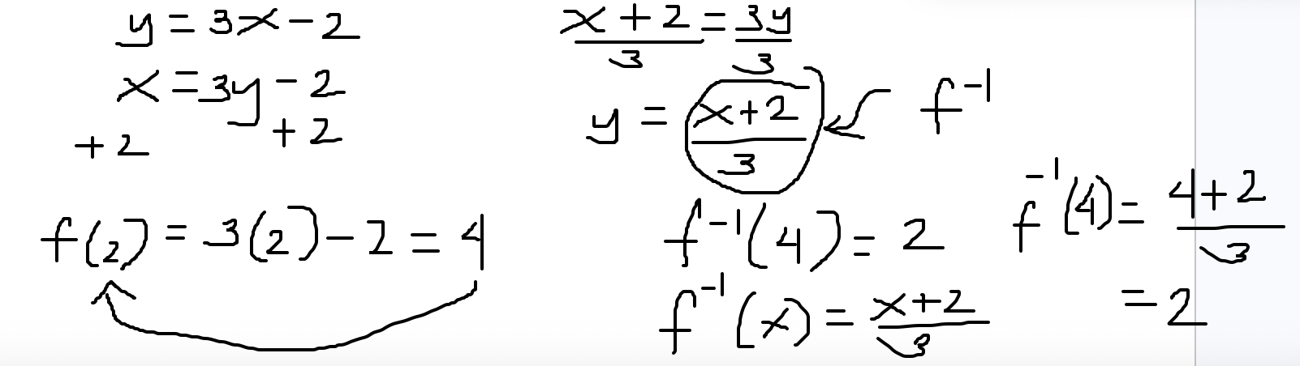

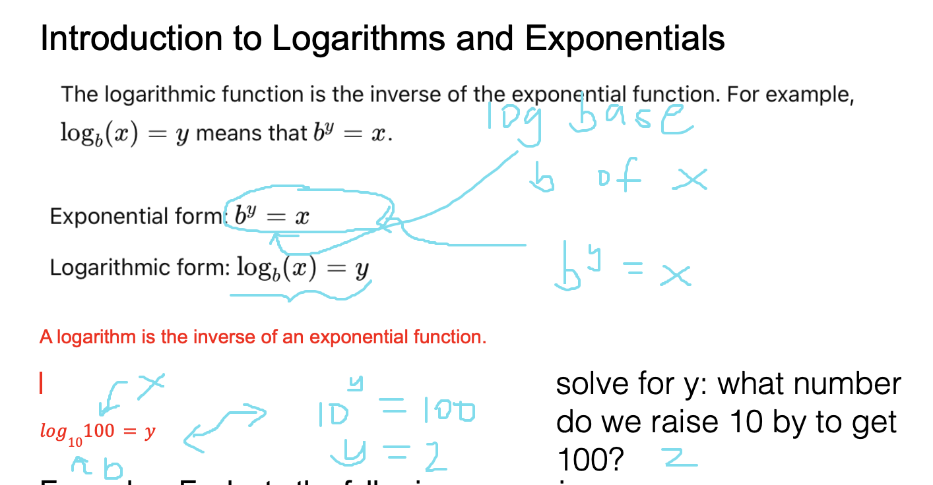

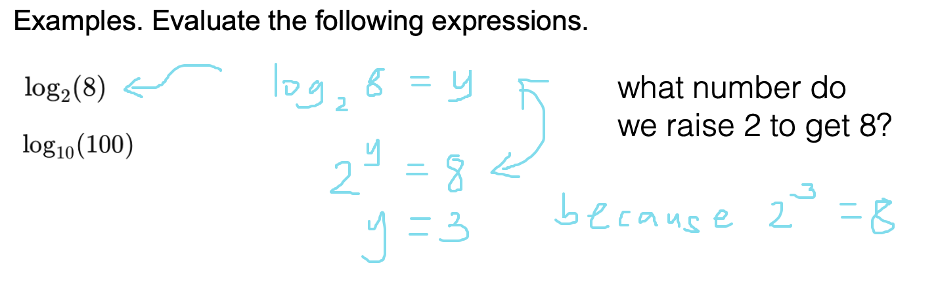Practice Problems
If there is no base, assume that the base is 10.

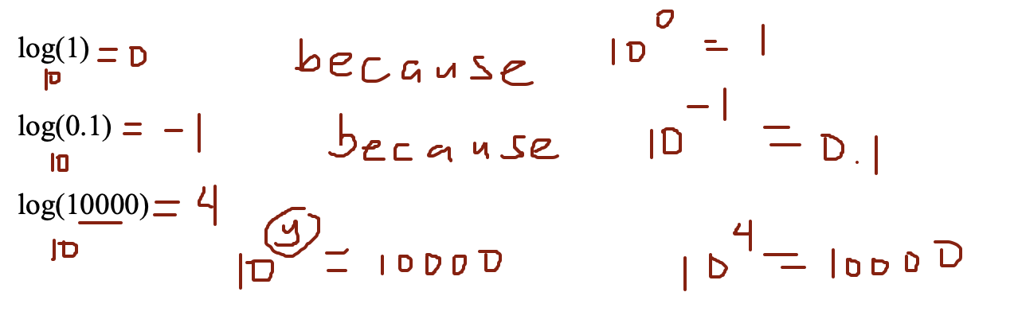
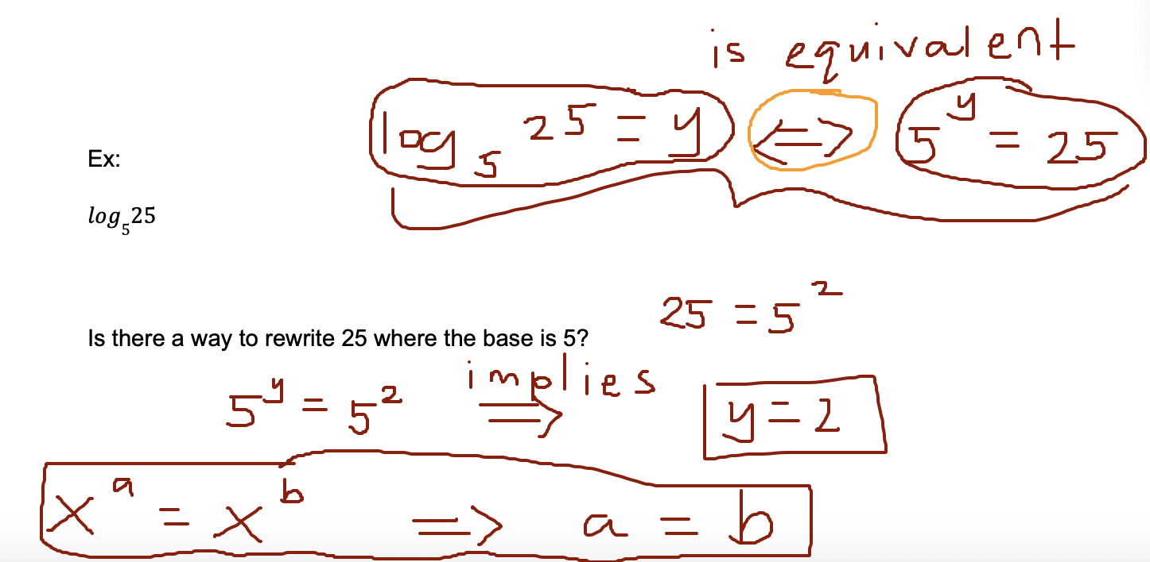
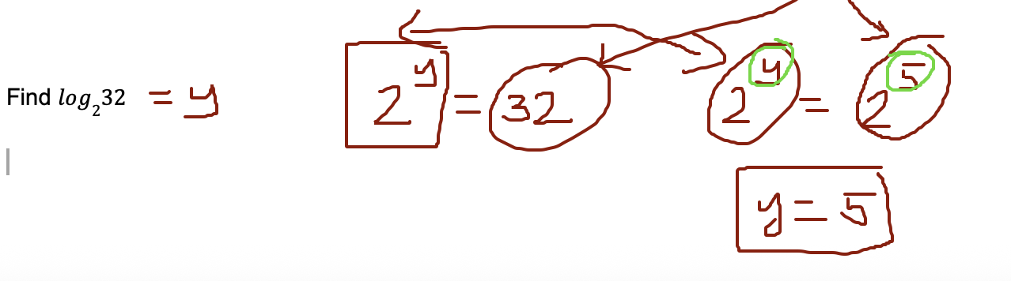

Graph of the Logarithm Function
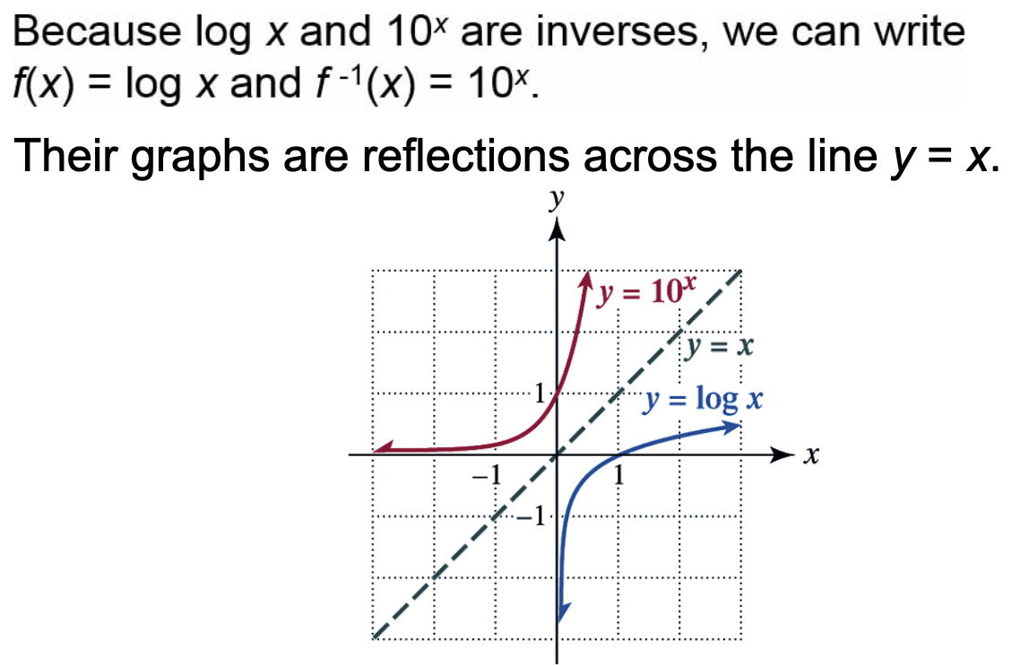

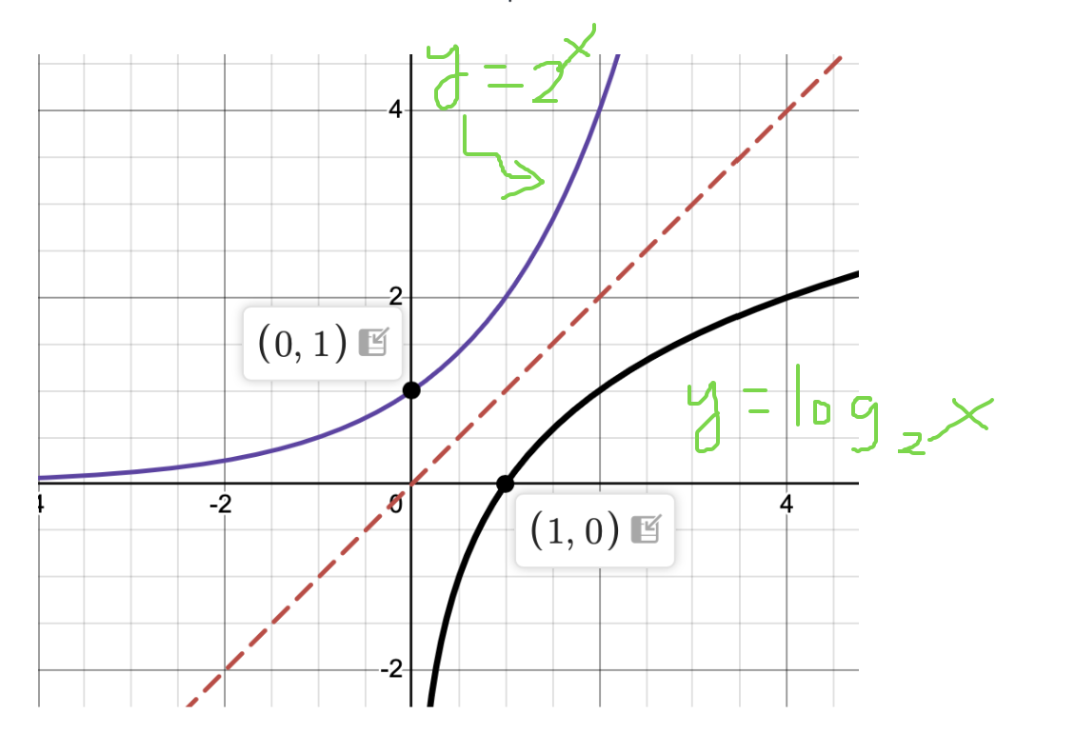

Common Logarithm with Base a
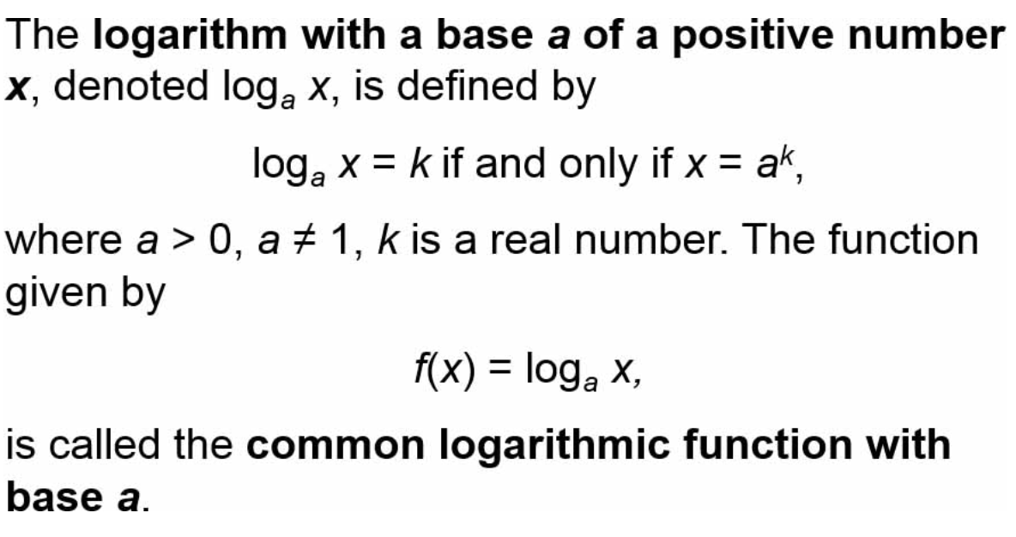

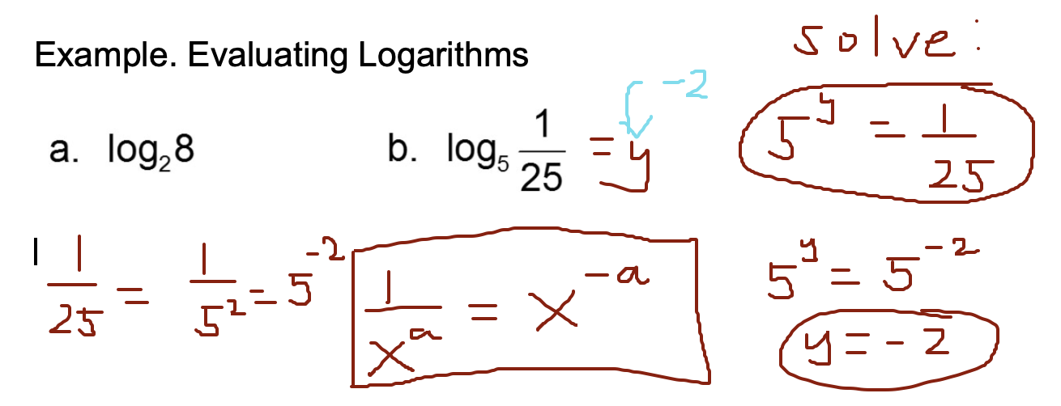

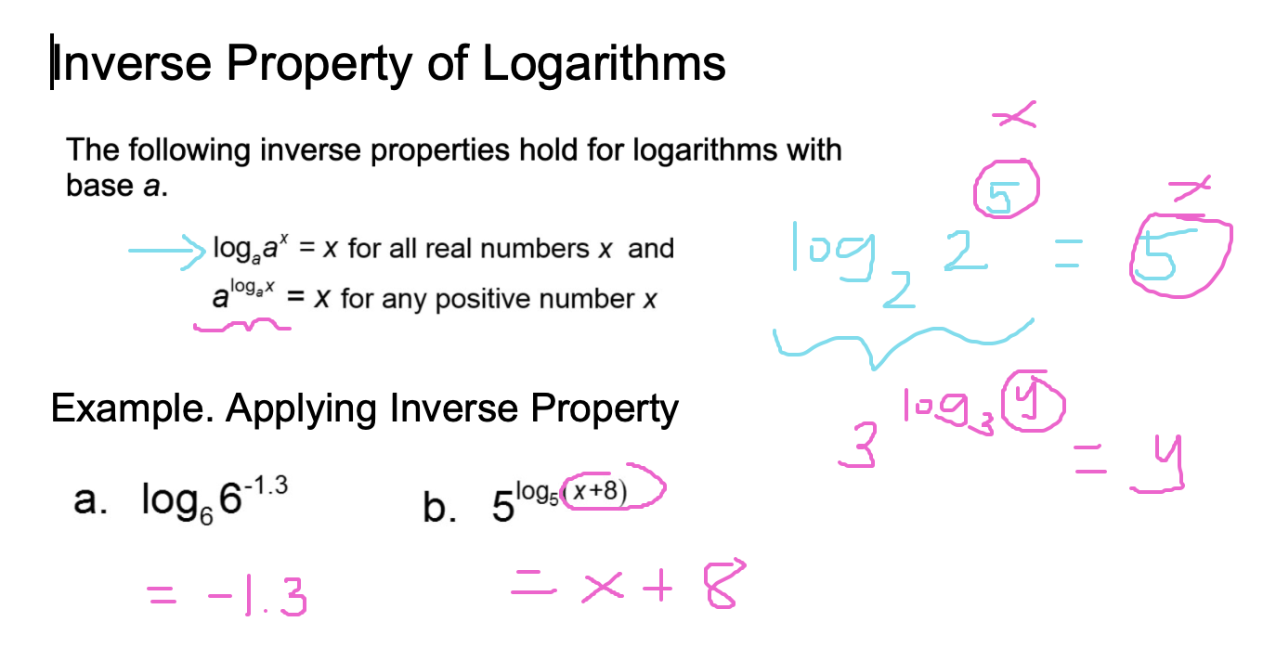

Solving Exponential and Logarithmic Equations

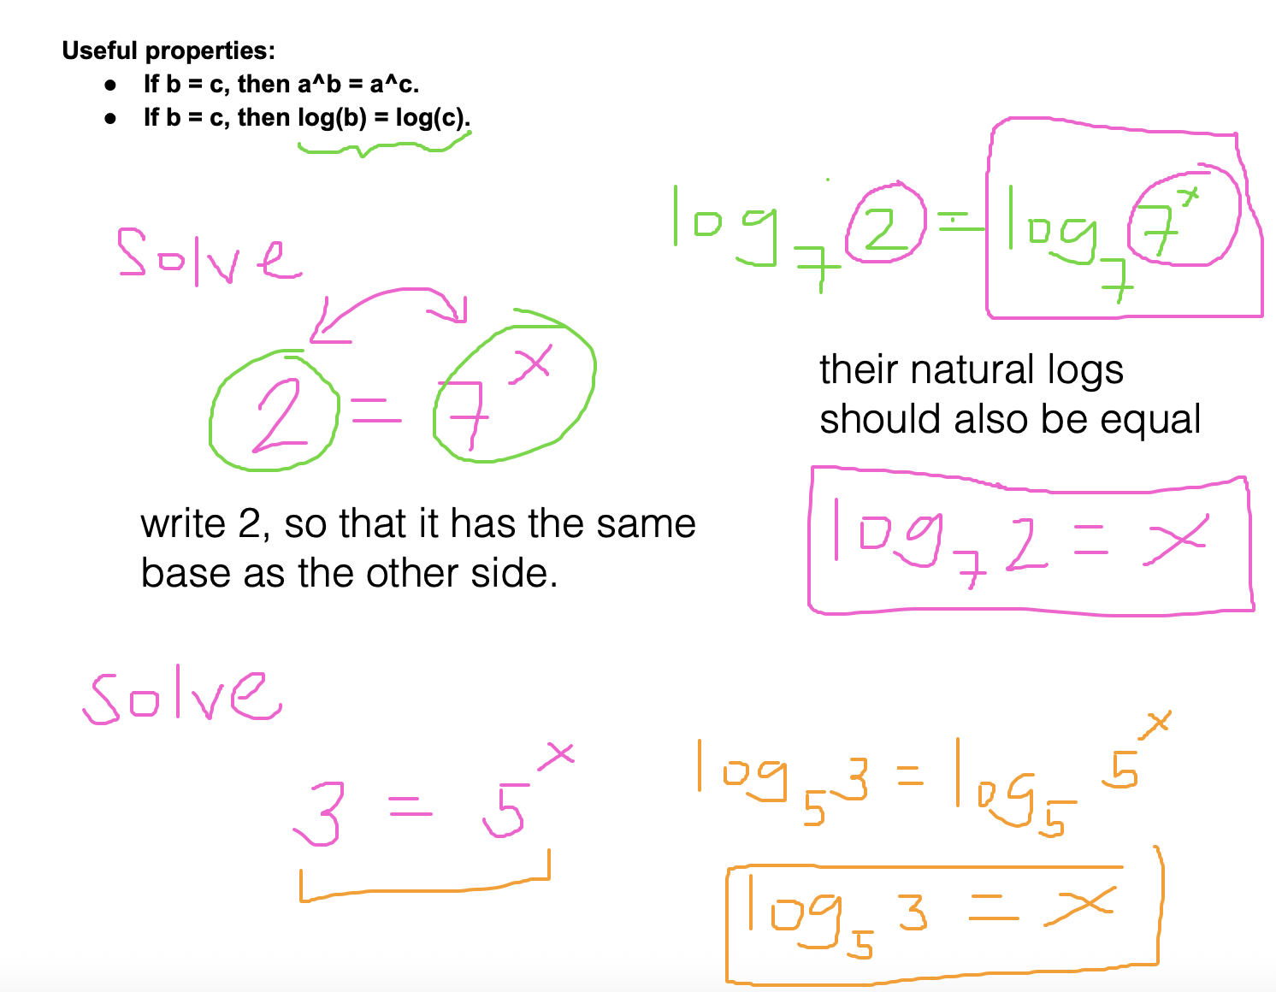

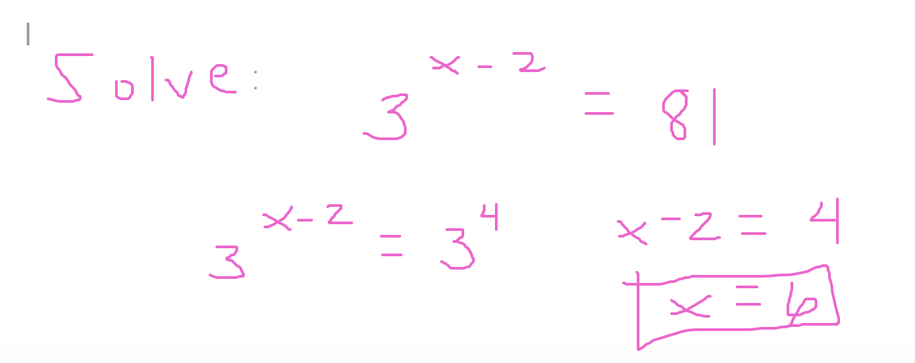

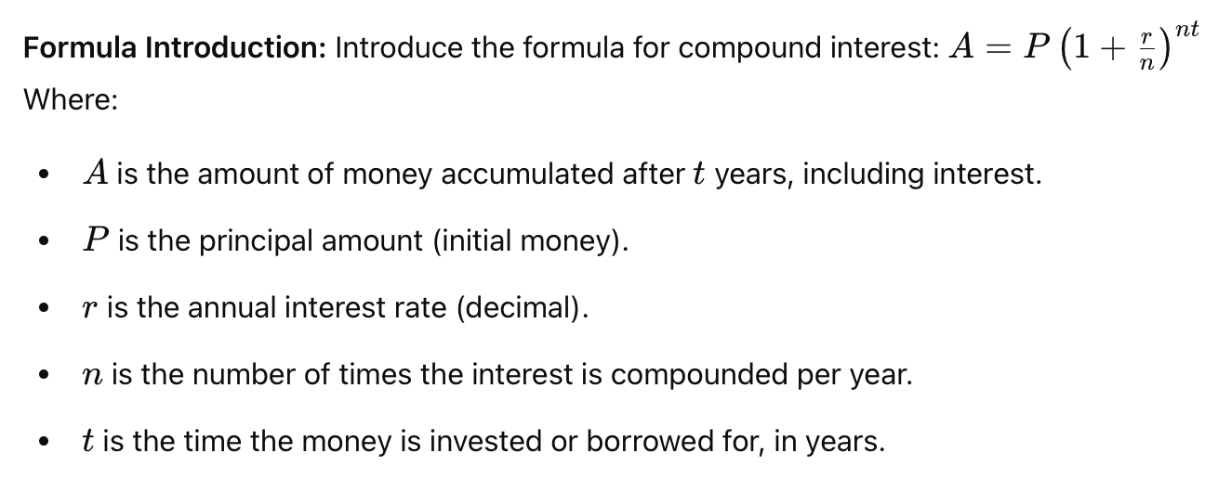

Compounding periods.

Compounding period is quarterly, n = 4, because there are 4 quarters in 1 year.
Compounding period is monthly, n = 12
Compounding period is weekly, n = 52

Example:

Suppose I have $5000 in my account. Assuming I leave it alone and interest is compounded daily, how much money I have in my account if the interest is 4% annually after 10 years.

Finding A.
P = $5000
r = 0.04
n = 365
t = 10

$A = 5000(1+ 0.04/365)^{365*10}=\$7458.96$

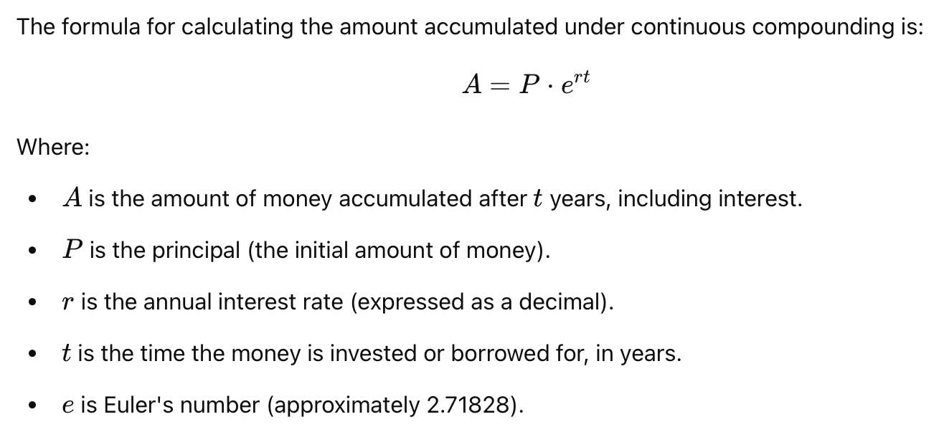

Suppose we're compounding continuously. What would we have gotten? (See previous problem)
P = 5000
r = 0.04
t = 10

$A = 5000e^{0.04*10}=$7459.12

Suppose that we invest $25000 in a fund that gives a 7% interest rate per year, compounded quarterly.
(a) Find how much money will be in the fund after 5 years.
(b) Instead of compounding quarterly, suppose it's compounded continuously. Find how much money is in the fund after 5 years.

(a)
P = 25000
r = 0.07
n = 4
t = 5
A = ?

$A = 25000(1+0.07/4)^{4(5)}=35,369.454$
(b)
$A = 25000e^{0.07(5)}$=$35,746.69

CONNECTION BETWEEN LOGS AND EXPONENTS

- LOGS AND EXPONENTS are inverses.

The equation for the amount of money you have if you have P = 25000 at a rate of 7% compounded continuously is

$A(t) = 25000e^{0.07t}$ (We don't know the time.)

For any given time t in years. I want to know how many years I would need to keep the money in the bank for my money to double.
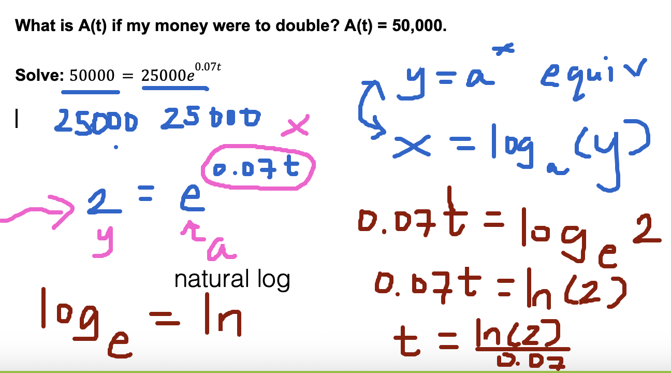

t = 9.9 years

